Week 9 Practical

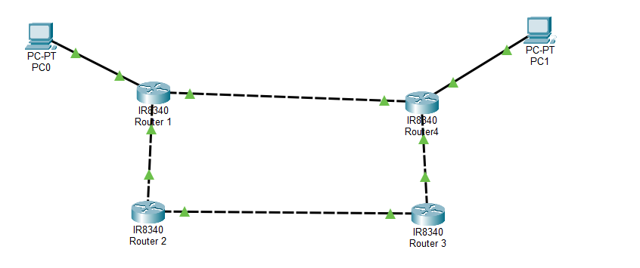

Task 1
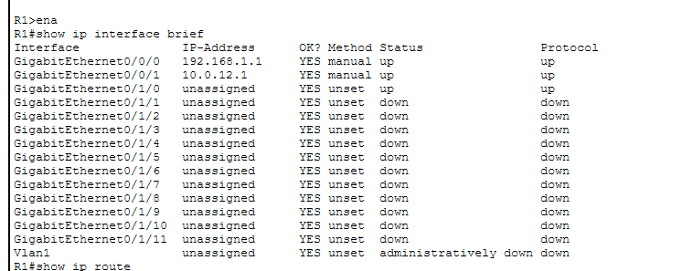

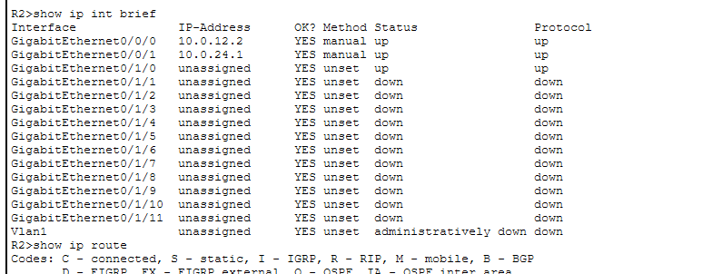

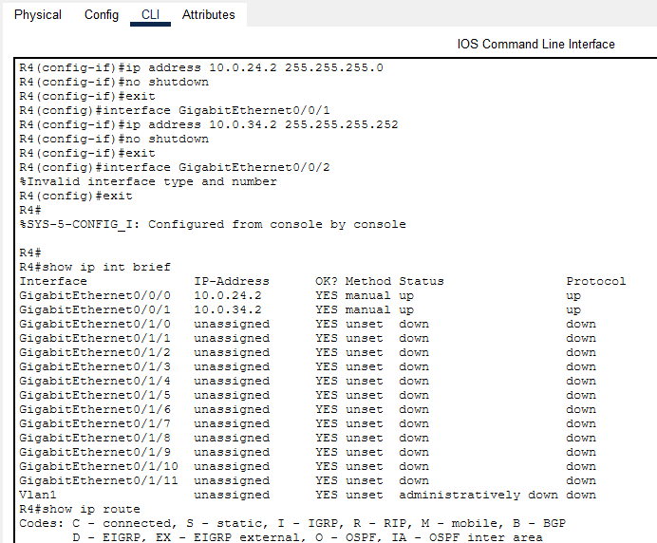
- Each active interface generates two routing table entries because of how IP routing works.
- Connected router- Ensures the router knows how to reach all devices on that subnet without needing another router.
Local Route- Ensures the router can correctly handle traffic destined for its own IP address (like management traffic, pings, or routing protocol communication).
- R4

7. By default, a static route has an administrative distance (AD) of 1. It is a measure of trustworthiness or preference among multiple routing sources.

8. When two static routes exist to the same destination with identical metrics, the router treats them as equal-cost routes. The routing table will include both static routes since they have the same destination and equal administrative distance/metric.
9. Routers follow a very structured decision-making process when choosing which route to use.
10. Purpose of a default route is to Simplify routing tables. Internet access: In corporate networks, the default route is used to send traffic to the firewall or edge router, which then forwards it to the ISP.

12. In most routing table outputs, the * symbol is used to indicate the active or candidate route that the router has chosen as the best path to reach a destination.

19. Per-destination load balancing - is the default because it avoids out-of-order packets, which can break applications like VoIP or TCP sessions.

